Country: **Mozambique**

Year: **2018**

Number of Observations: **6196**

Number of Clusters: **5**

Number of variables used: **22**

Distance used: **Hamming**

**Variables used in the algorithm:** hv206,hv207,hv208,hv209,hv210,hv211,hv212,hv227,hv243a,hv243b,hv243e,hv244,hv246,hv246b,hv246d,hv246e,hv246g,hv247,sh116a,sh130d,water,toilet,floor,roof,cookfuel,wall

Binary variables with less than 4% class imbalance excluded

hv246a-g variables besides hv246 for collinearity

**Summary of Top Cluster Configurations (ranked by ASW)**

| **Cluster #** | **ASW** | **Variable 1** | **Variable 2** | **Variable 3** | **Variable 4** |
| --- | --- | --- | --- | --- | --- |
| **1** | 0.961797335756257 | hv208 | hv209 | hv212 | hv243a |
| **2** | 0.961332327520986 | hv208 | hv209 | hv243a | hv243e |
| **3** | 0.958092742496089 | hv206 | hv209 | hv212 | hv243a |
| **4** | 0.957581798701321 | hv206 | hv209 | hv243a | hv243e |
| **5** | 0.944901473996421 | hv206 | hv209 | hv212 | hv227 |
| **6** | 0.944375055373193 | hv206 | hv209 | hv227 | hv243e |
| **7** | 0.943876259877333 | hv208 | hv209 | hv212 | hv227 |
| **8** | 0.942782740588379 | hv208 | hv209 | hv227 | hv243e |
| **9** | 0.941301735499448 | hv208 | hv212 | hv243a | hv243e |
| **10** | 0.938555204312555 | hv209 | hv212 | hv243a | hv243e |

**Distribution of ASW values in all clusters in Mozambique**

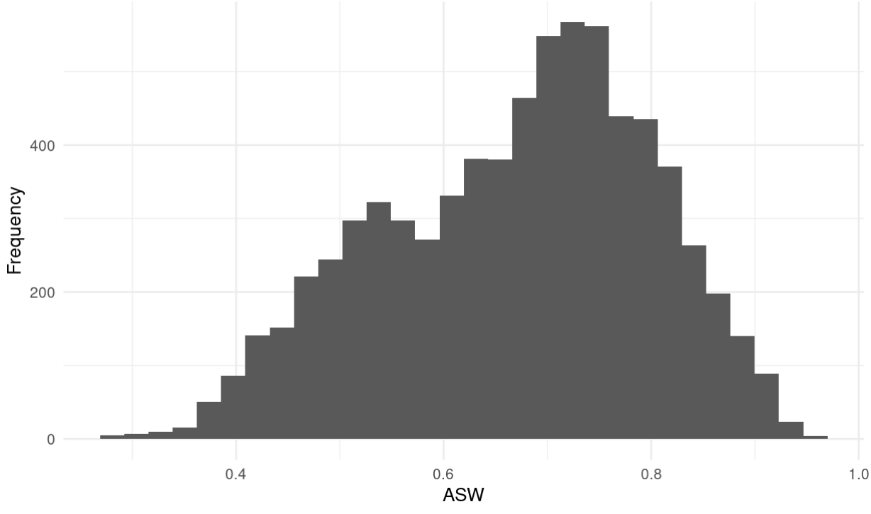

**Marginal Distributions**

| Variable | Description | % time in top clusters | Distribution |
| --- | --- | --- | --- |
| hv206 | Has electricity | 40% | Binary,35.9% 1s (or yes) |
| hv208 | Has television | 50% | Binary,33.2% 1s (or yes) |
| hv209 | Has refrigerator or freezer | 90% | Binary,23.7% 1s (or yes) |
| hv212 | Has car/truck | 60% | Binary,6.5% 1s (or yes) |
| hv227 | Has mosquito bed net for sleeping | 40% | Binary,89.2% 1s (or yes) |
| hv243a | Has mobile telephone | 60% | Binary,70.4% 1s (or yes) |
| hv243e | Has a computer | 60% | Binary,9.5% 1s (or yes) |

**Summary of variable distributions in top clusters**

Currently our method is choosing five distinct clusters of individuals within each cluster variable configuration. Here are the medioids for each of these five clusters:

**Cluster #1 Configuration**

| **Config#** | **Node** | **hv208** | **hv209** | **hv212** | **hv243a** | **Proportion** |
| --- | --- | --- | --- | --- | --- | --- |
| **1** | 1 | 0 | 0 | 0 | 0 | 29.4% |
| **2** | 1 | 0 | 1 | 0 | 0 |
| **3** | 1 | 1 | 0 | 0 | 0 |
| **4** | 2 | 0 | 0 | 0 | 1 | 37.9% |
| **5** | 2 | 0 | 0 | 1 | 1 |
| **6** | 2 | 0 | 1 | 0 | 1 |
| **7** | 3 | 0 | 1 | 1 | 1 | 5.5% |
| **8** | 3 | 1 | 1 | 1 | 0 |
| **9** | 3 | 1 | 1 | 1 | 1 |
| **10** | 4 | 1 | 0 | 0 | 1 | 10.0% |
| **11** | 4 | 1 | 0 | 1 | 1 |
| **12** | 5 | 1 | 1 | 0 | 0 | 17.3% |
| **13** | 5 | 1 | 1 | 0 | 1 |